|  |
| --- |
| Funtoo.com |
| Online Mobile Shopping Website. |
| Project Report |
|  |
| **Tejas.J.Ghalsasi** |
| **4/13/2013** |

|  |
| --- |
| **Information Technology Department , Fr. Conceicao Rodrigues college of Engineering.** |

**Name: Tejas .J. Ghalsasi.**

**Roll no.:6483**

**Class: S.E. I.T.**

**Problem Statement:**

FUNTOO.com is a online shopping website with enormous database of mobile phones to offer. They are the vendors of various Mobile phones ranging from the widest range to suit your needs.   
They have a dedicated set of Administrators to handle your needs professionally.   
Their facilities include COD(cash on delivery),CCOD(credit card on delivery) and a User-friendly online GUI to make it easier for our customers to login and browse Their website   
They also have a well equipped system to handle your transactions & a Hit counter on homepage to show the popularity of the site.   
***SO HAPPY SHOPPING WITH FUNTOO.com***

**Tools used:**

We have used Netbeans 7.2 IDE along with Glassfish server.We also used Edit+ in the prior parts of our project.The browser used is Google Chrome Browser.

The project was done using JSP(Java Server Pages), HTML5 , CSS and JavaScript Technologies for the front end and SQL for the backend.

The backend database is built up using the derby database provided by Netbeans. The Language used to communicate with database is SQL.

**Explanation of UI of project along with selected important screenshots:**

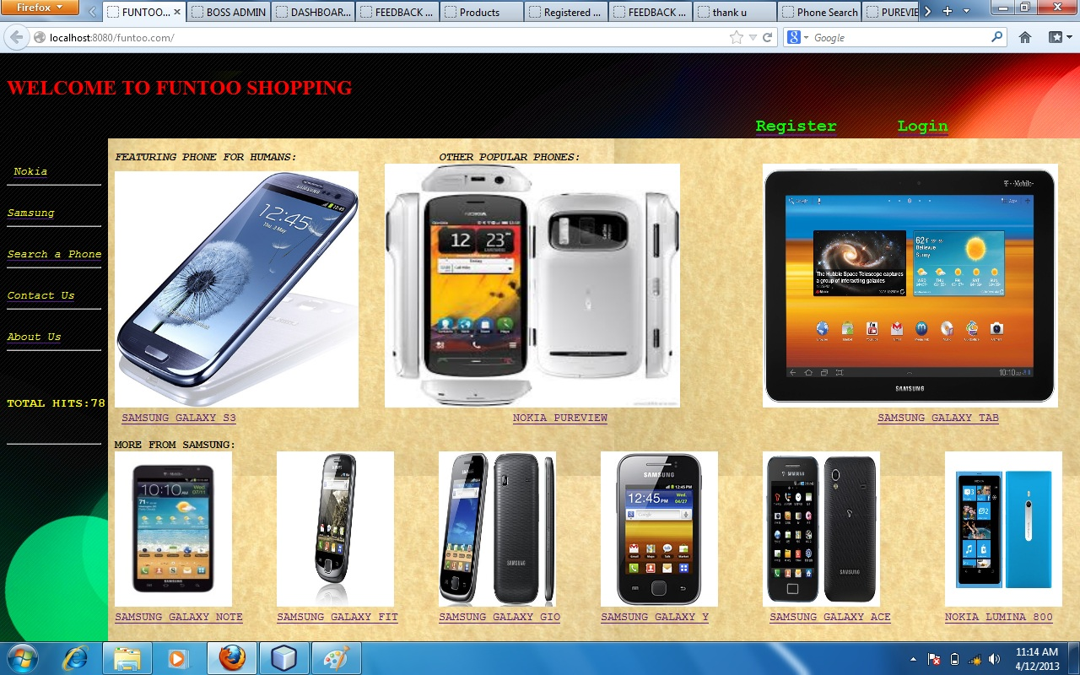

Our home page is made up of 3 main frames that is the TOP,LEFT and RIGHT.The top frame consists of a welcome header along with hyperlinks to register or login.Every hyperlink opens the required page in a new tab.

* The left frame is a navigator y panel which opens phones with nokia when nokia is clicked,the same with Samsung.
* Search a phone enables user to search a phone present in the database. 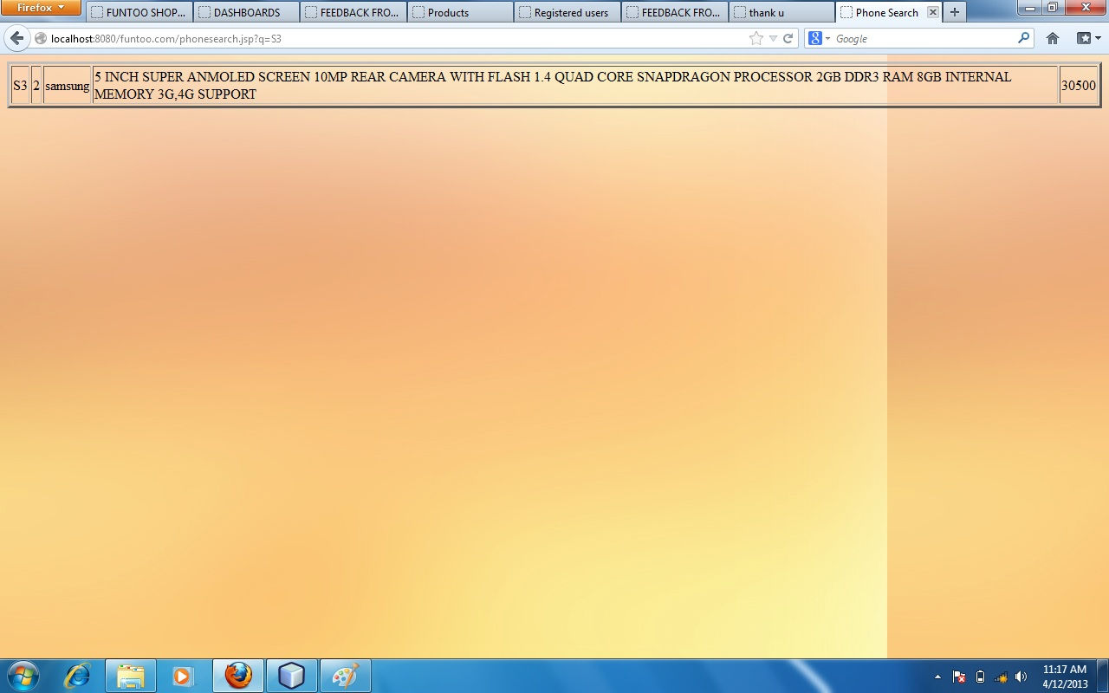
* The contact us link is a hyper link to the feedback form which inserts the values into the database. 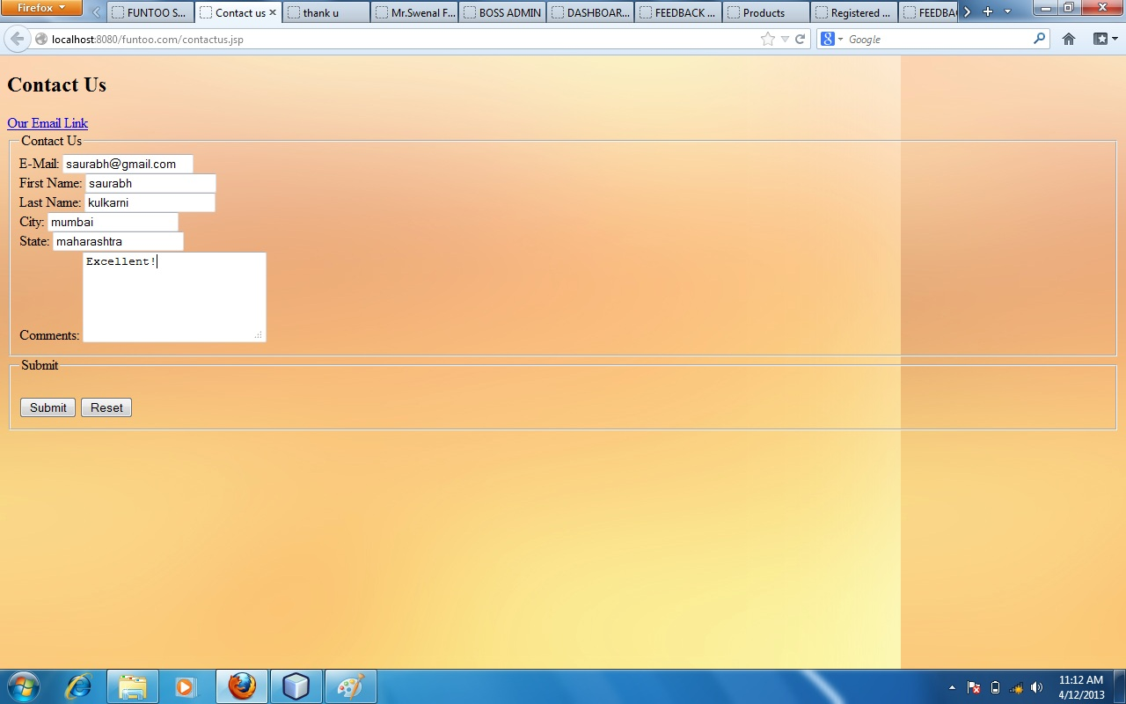
* The aboutus is our colorfull page it has the problem statement along with the project members as board of directors on the page. 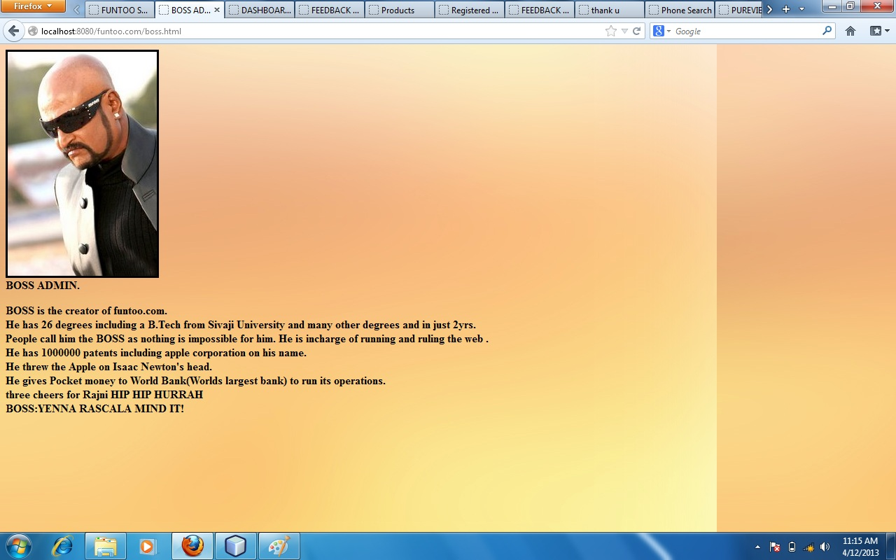
* The right frame has an array of phones for display the hyperlinks lead to the phone photo followed by phone specifications.
* The whole project has external css where the background of peach color is the standard.
* The user has to first register .The register page has a client side javascript validatory check .It performs a check on important fields like email and password.Once the user registers,his information is stored in the database table of cust and he is eligible to login along with his password through the login page. 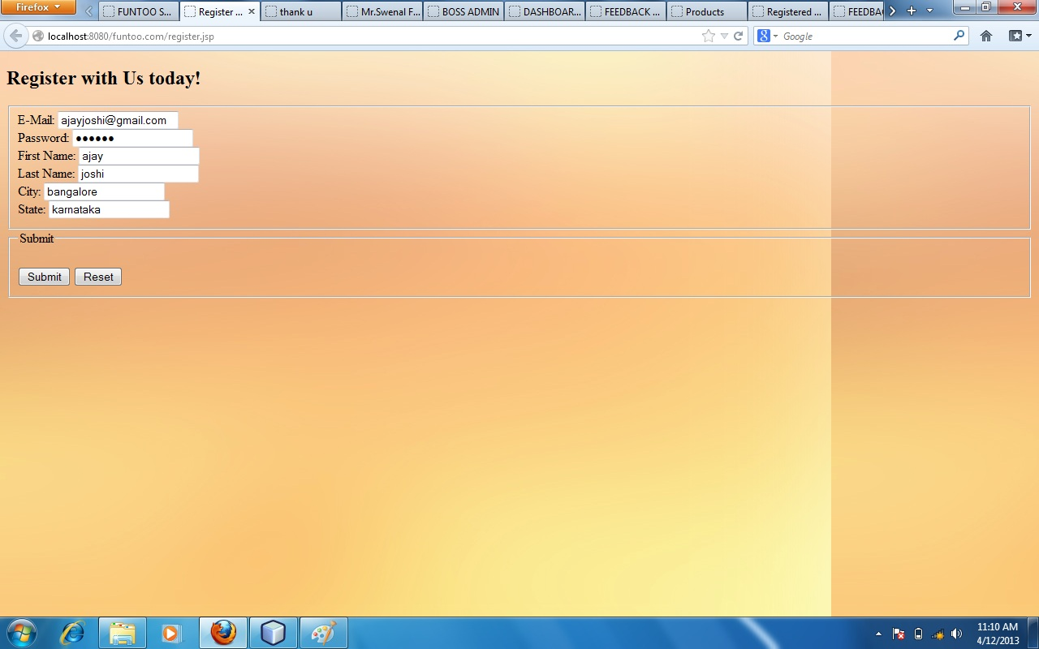
* The login page is also having javascript validations . once the user logs in the validate.jsp authenticates his entry in the database by a doublecheck using .equals() method to prevent SQL INJECTIONS.There is a different login user name and password for the admins.ie email: [crazy4@gmail.com](mailto:crazy4@gmail.com) password:mangalore
* The page validates the above case specially.

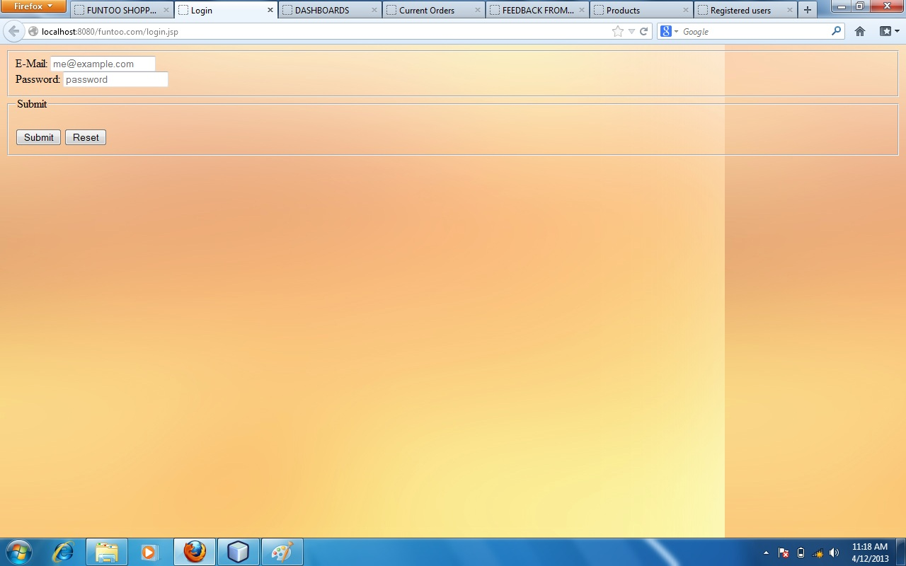

* After the customer logs in,A session object is created using the jsp sessions,he is welcomed on a customer dashboard.The dashboard allows the customer to view all the products ,to place an order or to logout.
* On clicking products the customer is directed to a page which retrieves the phone data from the database and presents it to the customer in tabular format. 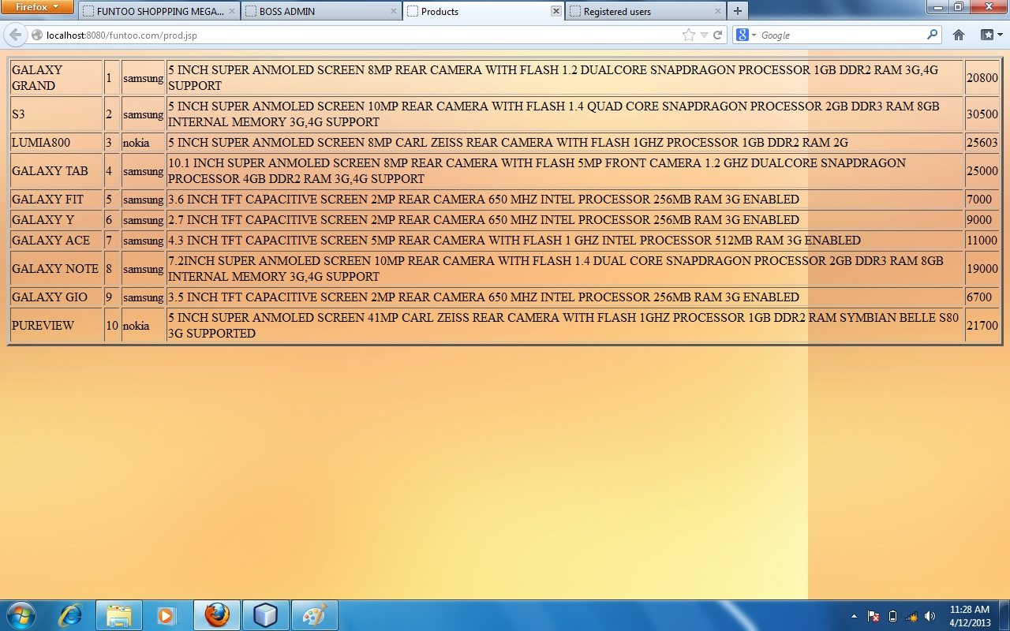
* On clicking place an order the customer has to fill details of a form.The customer enters the phone he wants and submits it.On submit the customer is directed to a Invoice page where his order can be printed using the print button.The page consists of the details of the customer and the phone specifications.This order is fed in the database table of Orders. If the customer enters a wrong Phone data wouldnt be displayed and the orders table wont be affected until the user enters a correct phone which is present in the database. 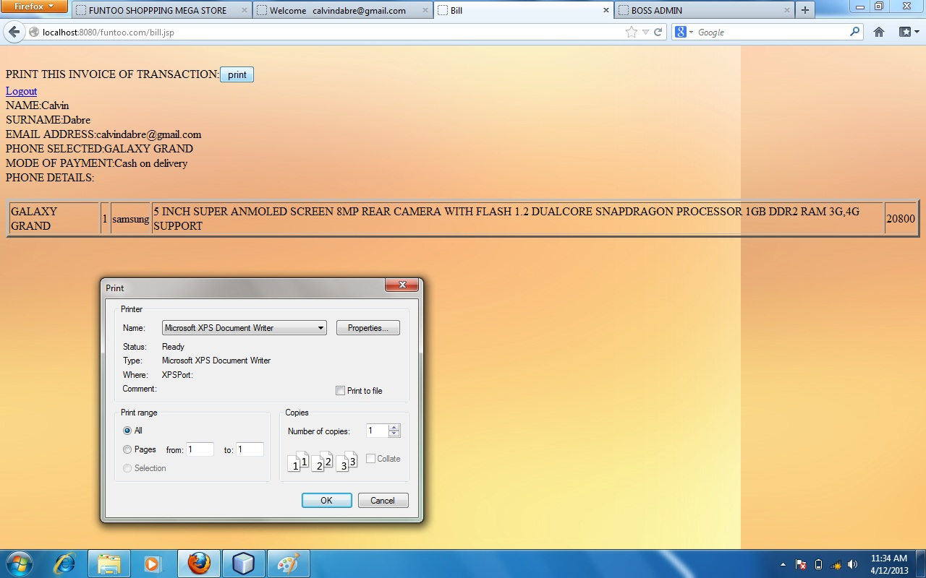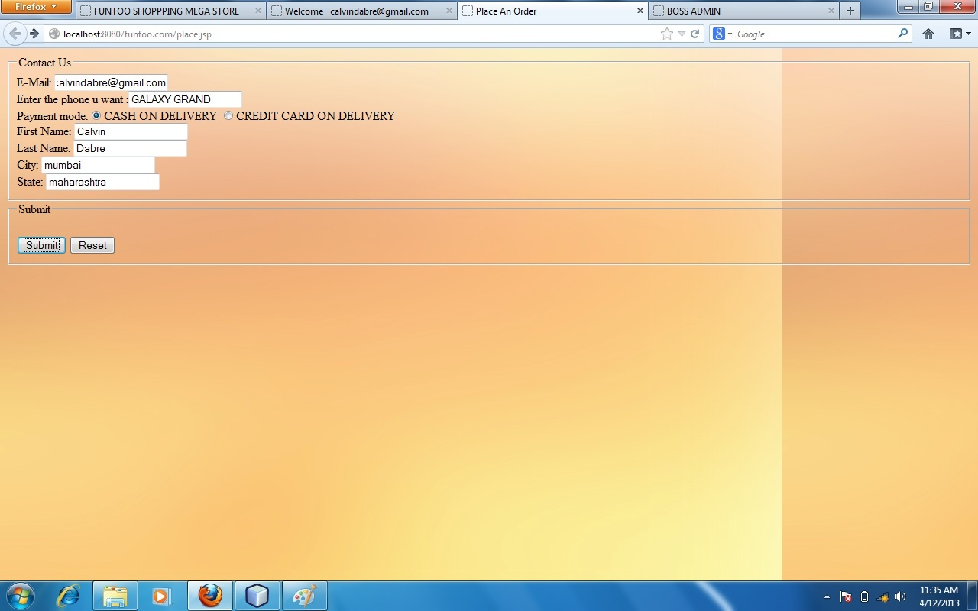
* On clicking logout,the window is closed thus prohibiting the customer to pressback again and access his info.

When the Admin logs in he is welcomed on admin dashboard .This dashboard allows the admin to view Registerd users,feedback from users, all the products,all the current orders and logout.

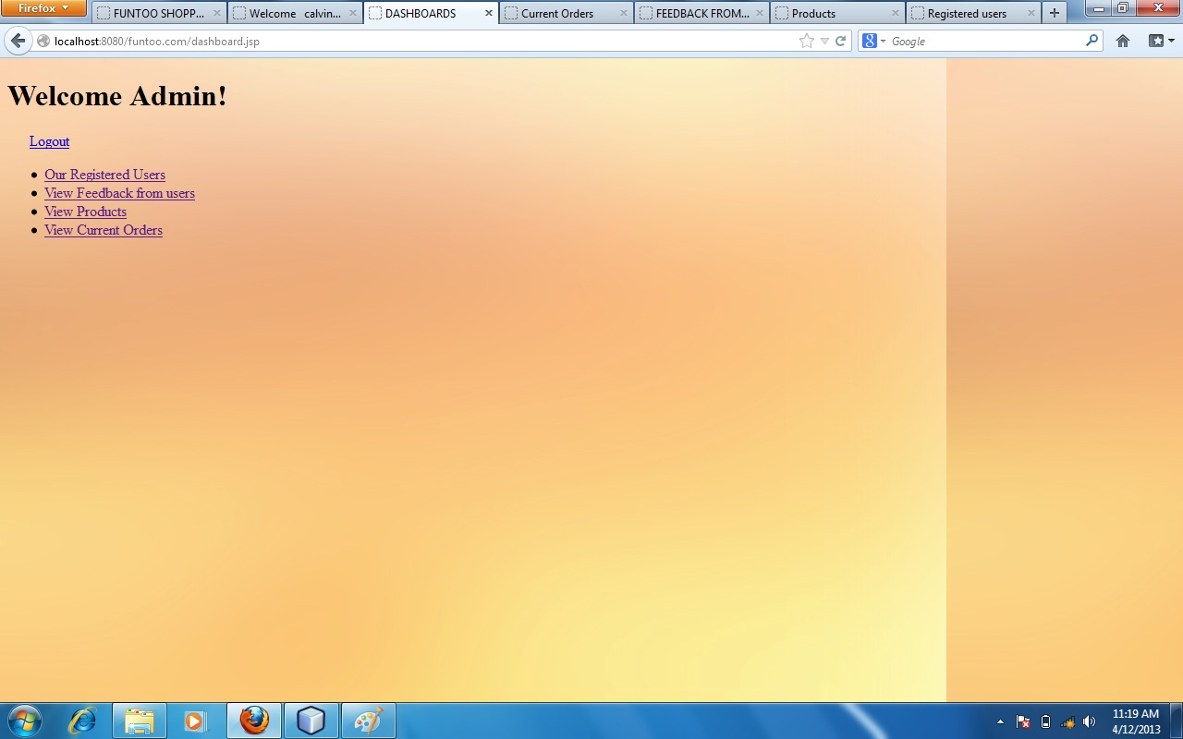

The Registered users opens a tab in which the admin can see who are the new registered users .this information is retrieved from the database 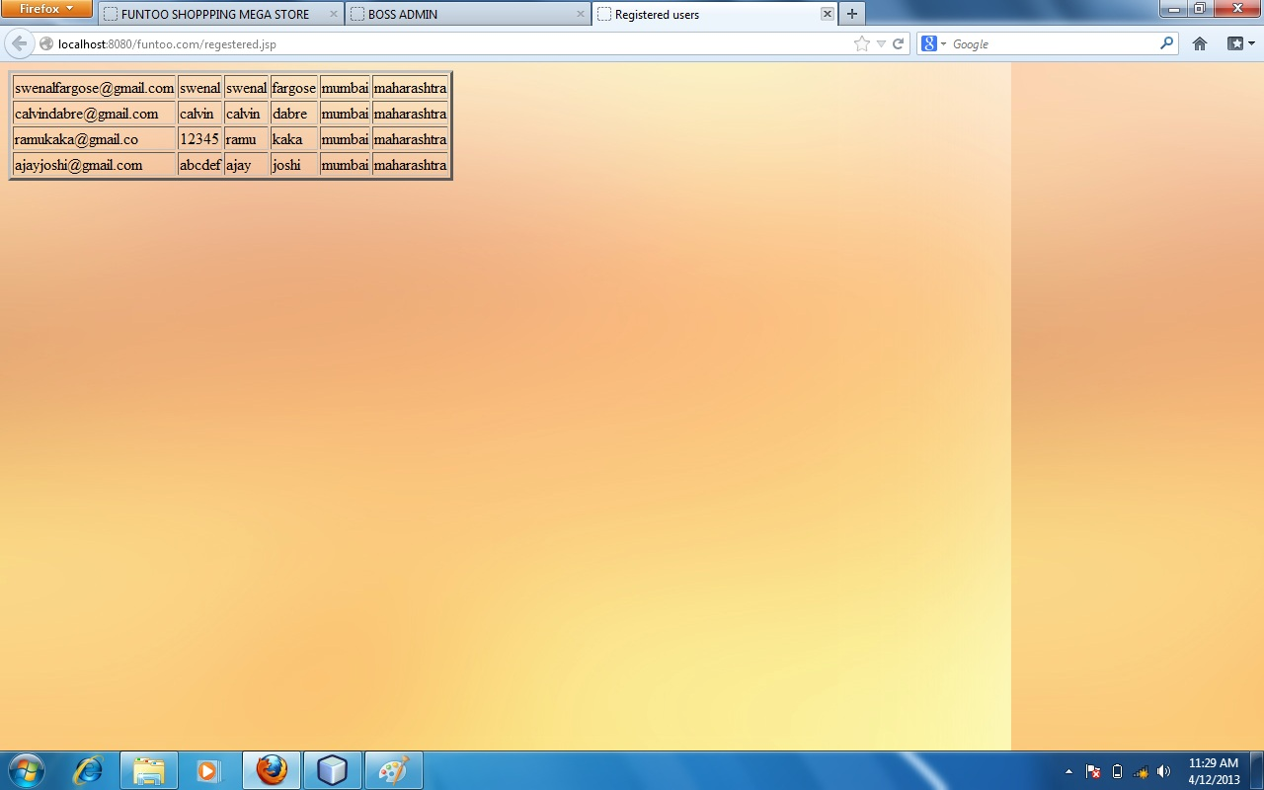

* The feedback directs admin to a page where the feedback is retrieved from the database. 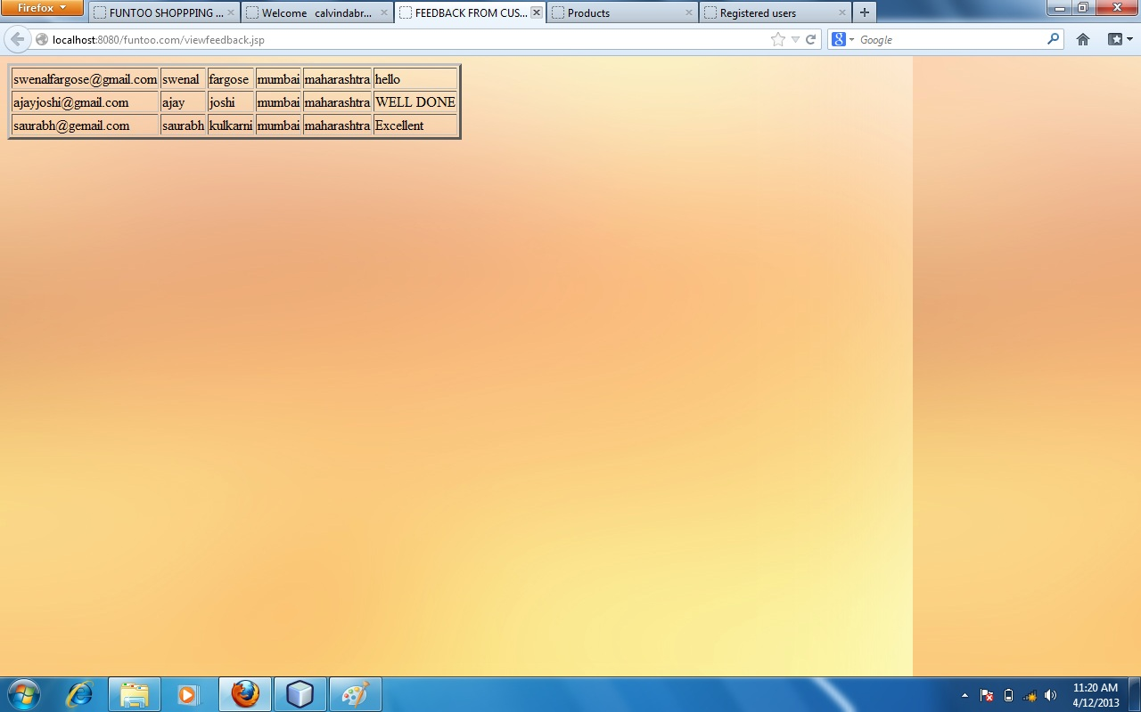
* On clicking products the products from the database are displayed which are same as customer. 
* The admin can view current orders by clicking view current orders.This retrieves the data from orders table from the database. 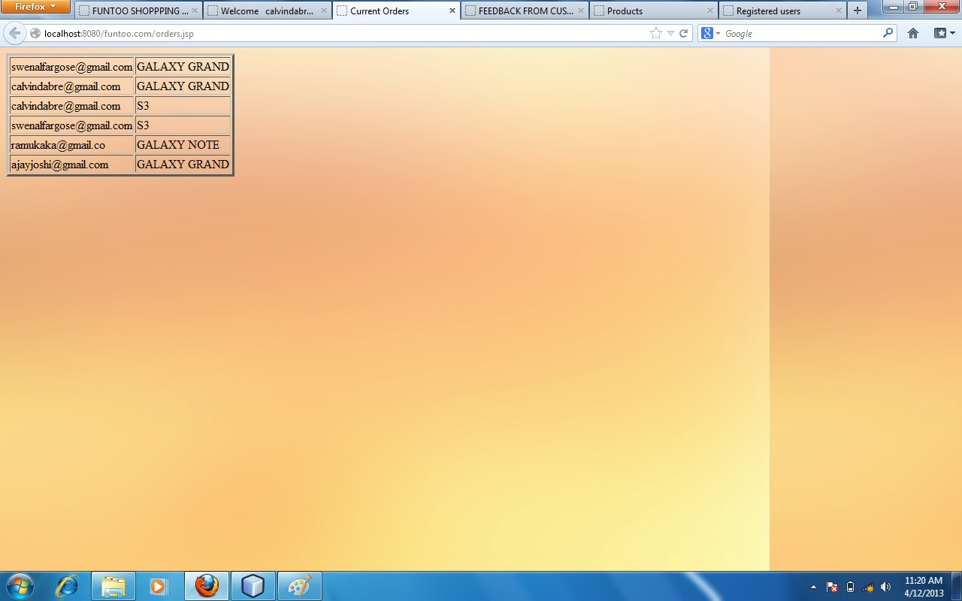

Once the admin is over he can logout.The window closes thus prohibiting re-entry inside.

**Explanation of database tables along with selected important screenshots**

The derby database is basically made up of 5 tables each connected using jdbc inside jsp.

The database name , password and the schema used was “tg” for simplicity purpose.

* The first table is hitcounter.It stores the hit values every time the main page is loaded.It is of varchar data type due to parsing problems.

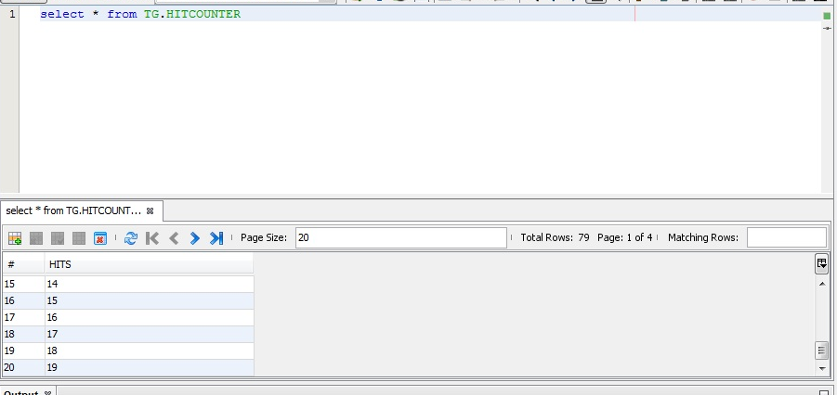

* The second table is the feedback table.It has 6 columns which store email , name , surname , city , state and comments.It does not have any primary key as 1 customer or a visitor may give feedback one or more number of times.

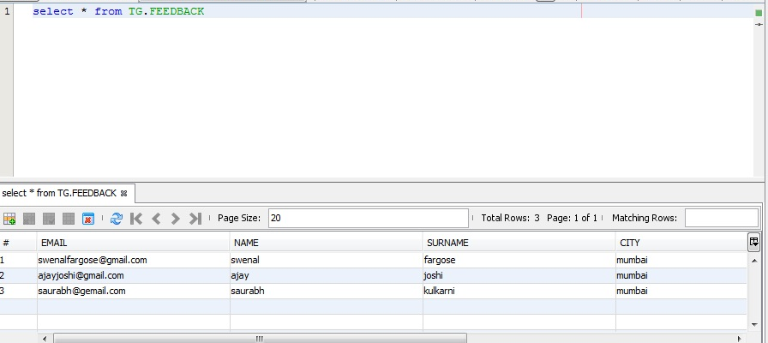

* The cust table is designed to store the login information of the customer who has registered.This table has 6 columns which store email , name , surname , city , state , password .

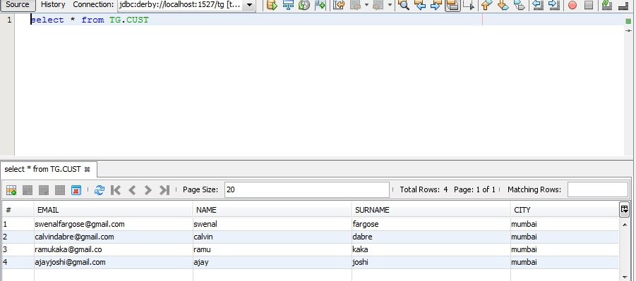

* The prod table consists the data of products.For sample purposes we have stored 10 products of 2 companies ie Samsung and Nokia.This table is the most accessed table.The details of the products include name, product no(primary key) , company, specifications, price.

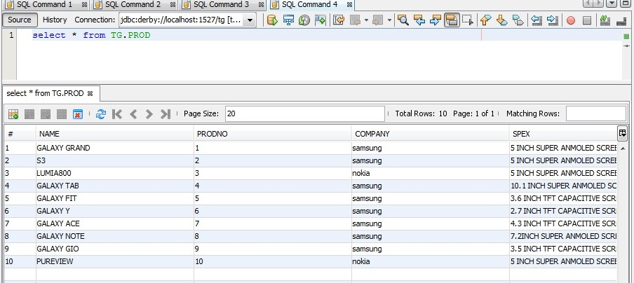

* The orders table shows the orders which the customers want.This information is fed from the orders.jsp page where the bill is printed.It has 2 columns namely Email and product no.Both the columns are primary keys of cust and prod table respectively.

